Operational manual for MAT 253 and Kiel IV carbonate device
v 1.0
By Stefano Crivellari
Introduction 1
1 Definition of the main components of the equipment 2
2 Lab general check-lists 5
2.1 Upon arrival 5
2.2 Upon departure 7
3 Handling samples, vials and magazine 9
3.1 Magazine sample distribution 9
3.2 Removing a magazine 9
3.3 Loading a magazine 11
3.4 Basic maintenance between acquisitions 12
3.5 Washing the vials 12
4 Handling liquid nitrogen 13
4.1 Safety concerns 13
4.2 Transfer LN₂ from secondary to primary reservoir 13
4.3 Preparing the reservoirs for LN₂ refill 14
5 Sequences and acquisition 15
5.1 Building a sequence and starting an acquisition 15
5.2 Running a leak test on a vial 17
5.3 Monitoring an acquisition check-list 17
6 Emergency operations 19
6.1 Emergency switch off of MAT253+Kiel IV 19
6.2 Switch on the MAT253+Kiel IV 20
6.3 Stand-by in case of potential energy drop 21
7 Troubleshooting 22
7.1 Compressed air leak 22
7.2 Leak rates are too high 22
7.3 Problem with the drop counter 23
8 Contact of Lab manager and Lab secretary 25

Introduction
The main objective for this document is to provide basic understanding of the most common procedures in operating the MAT253 and Kiel IV carbonate device. Each section can be taken in stand-alone mode depending on your need. For any question or concern please enter in contact with stefano.crivellari@usp.br (Lab Manager).

Definition of the main components of the equipment
In the following pictures each component of the Kiel IV and liquid nitrogen system are being defined and later used in the manual. Please take your time to go through each figure caption in order to familiarize with the names.

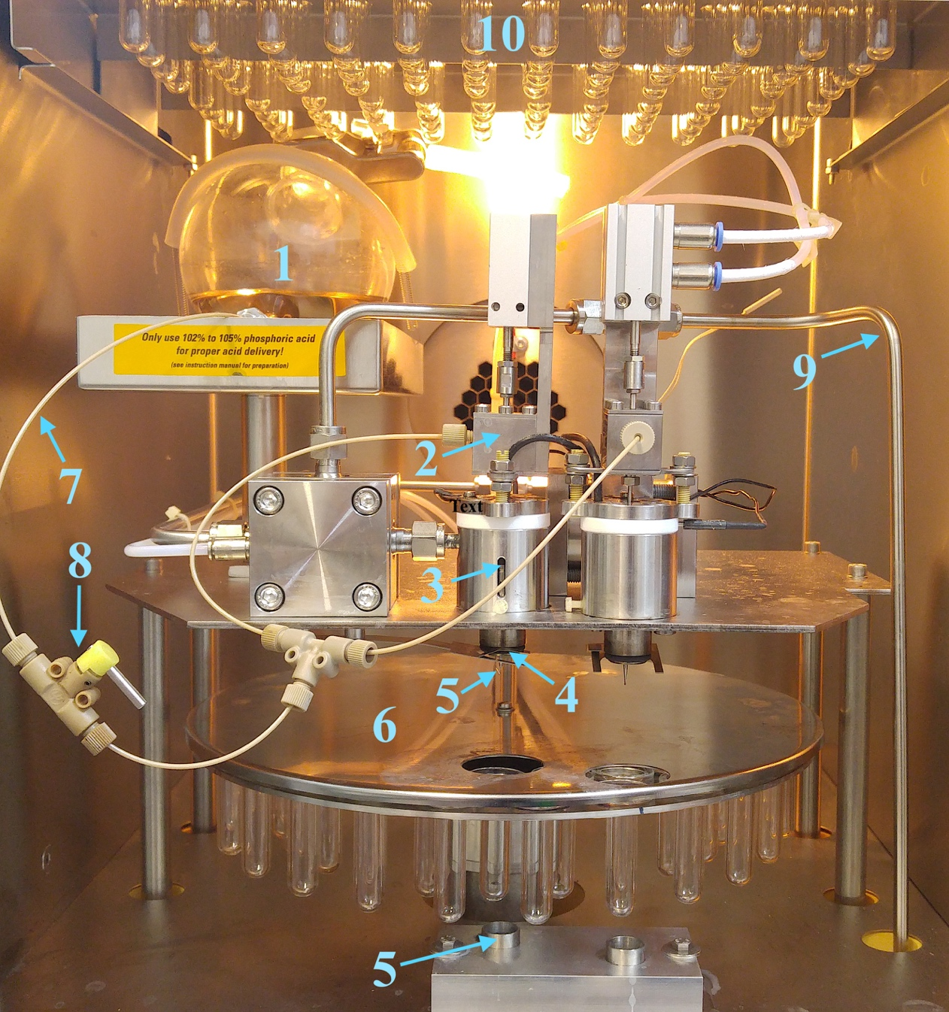
Figure 1. Main components of the Kiel IV oven. 1 Phosphoric acid reservoir. 2 Acid valve line 1(note an identical component for the line 2). 3 Acid block. 4 O-ring. 5 Acid needle and drop counter (see Fig. 2 for better details). 6 Sample magazine. 7 Acid capillary. 8 Acid flow valve. 9 Sample line. 10 Sample trays.
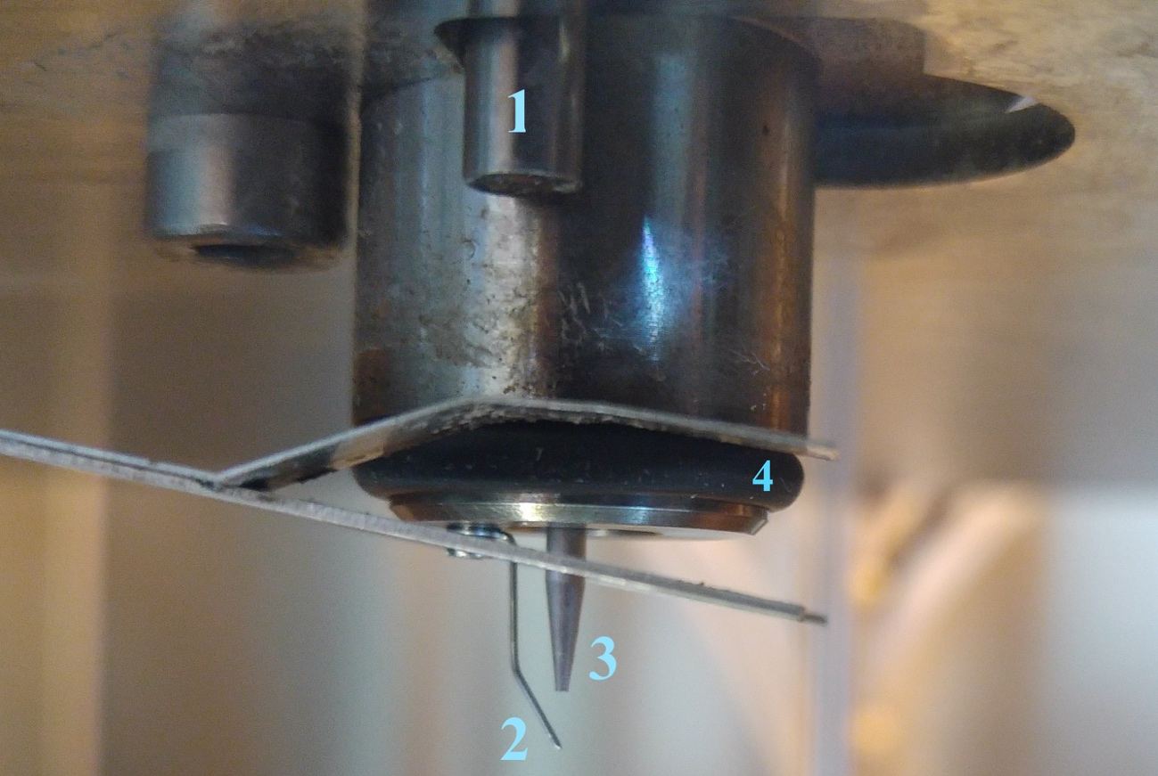
Figure 2. Components of the acid block (Fig. 1 item 4). 1 proximity sensor. 2 Drop counter. 3 Acid needle. 4 O-ring.
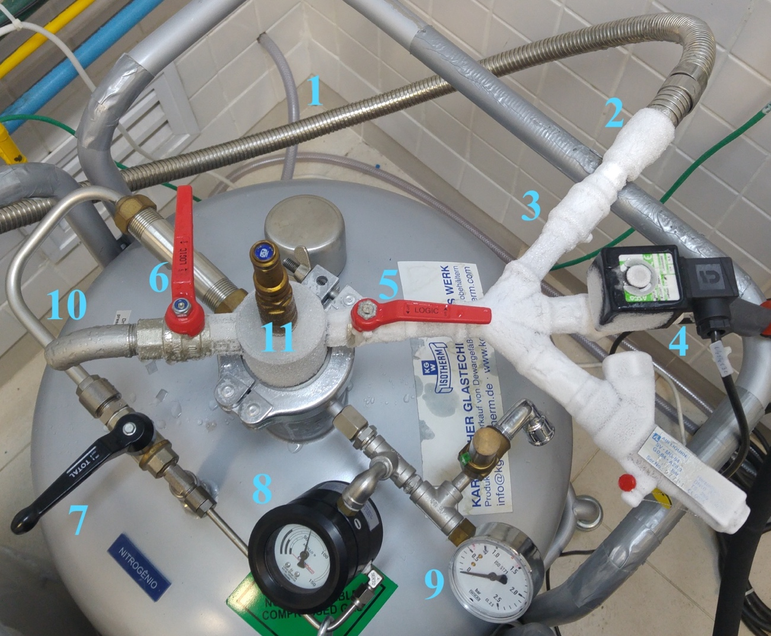
Figure 3. Component of the primary liquid nitrogen (LN₂) reservoir. 1 LN₂ transfer hose. 2 LN₂ transfer hose connection. 3 LN₂ transfer valve (not visible because underneath the pipe). 4 Solenoid valve for LN₂ transfer to the Kiel IV. 5 Deep LN₂ access valve (access to the bottom part of the reservoir). 6 Shallow LN₂ access valve (vent valve for pressure release). 7 Manual pressure control valve. 8 LN₂ level gauge. 9 Pressure gauge. 10 Vent. 11 First safety valve.
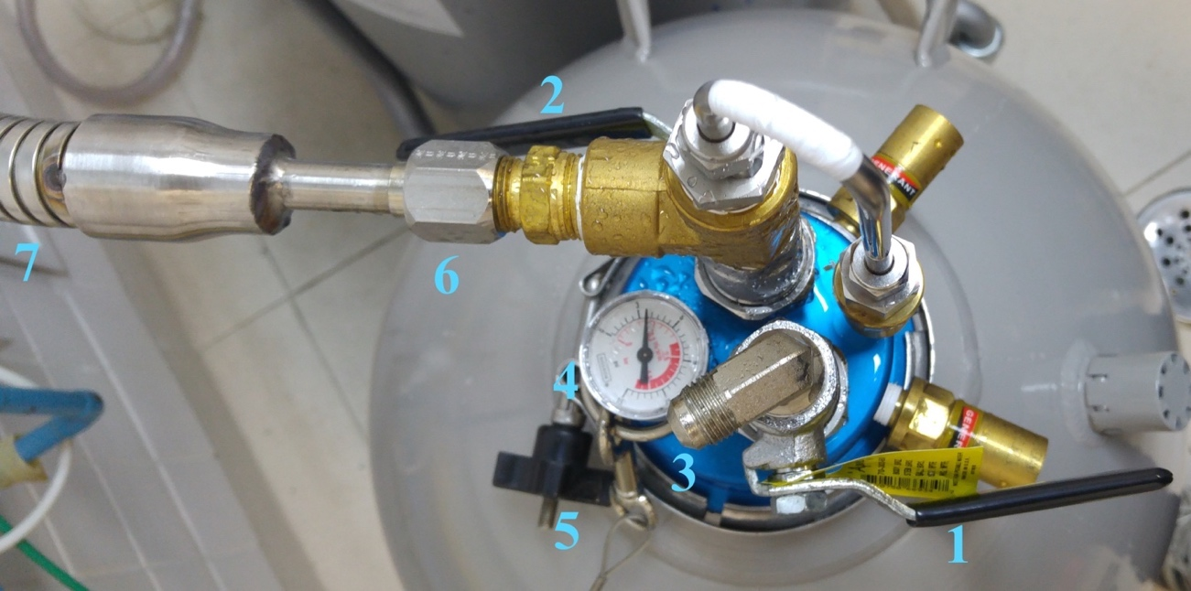Figure 4. Main components of the secondary liquid nitrogen (LN₂) reservoir. 1 Vent valve. 2 LN₂ transfer valve. 3 Vent. 4 Pressure gauge. 5 collar screw. 6 LN₂ transfer hose connector. 7 LN₂ transfer hose.

Lab general check-lists

Upon arrival
- Check if the air conditioning and dehumidifier are working properly. The dehumidifier can be found behind the MAT253. If the dehumidifier is not working that is because the water reservoir is full. If so, remove it and empty it in a sink.
- Gauge the temperature of the lab by pointing the IR thermometer to the wall of the lab. Temperature should be around 23 °C. The IR thermometer can be found in the first drawer of the black cabinet).
- Check the control panels in both the Kiel and MAT and make sure the vacuum pumps are working properly. You should see all green lights (Fig. 5).

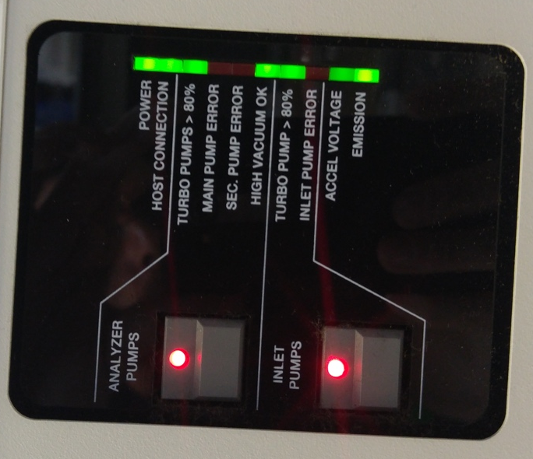
Figure 5. Control panel for the MAT253 and Kiel IV. Indicating (from top to bottom) power on, connection to the computer, ion surce turbo pump speed, high vaccum condition in the ion surce, dual inlet turbo pump speed, high voltage on.
- Check the water trap in the compressed air line (Fig. 6). Press gently to the bottom of the water trap to evacuate the trapped water. IMPORTANT: Normally there should not be much water inside the trap but if you see a large quantity of water this means that there is a leak in the compressed air system inside the MAT or the Kiel. Refer to section 7.1 for solving the problem.

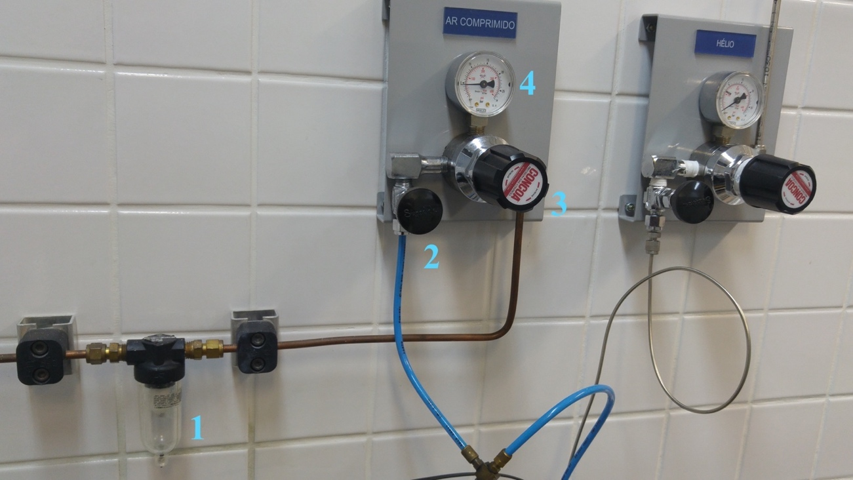
Figure 6. Compressed air line components. 1 Water trap. 2 MAT and Kiel IV access line. 3 Pressure regulator (set to 5 bar). 4 Pressure gauge.
- Lay your ear in firm contact with the pressure regulator knob (Fig. 6 item 3). If you hear a hiss this means there is a leak somewhere in the MAT or Kiel IV. Refer to section 7.1 for troubleshooting the problem.
- Check the LN₂ level (Fig. 3 item 8) and see if there is enough LN₂ for the analyses. If the level is below ca 40 liters of LN₂, proceed with a transfer of LN₂ from the secondary reservoir to the primary reservoir by following the instructions in section 5.2.
- Look inside the Kiel IV oven window and check (i) if you see visible acid liquid around the acid capillary line (Fig. 1 item7 and 8) this may indicate acid leak somewhere (ii) If the connected vial has large quantity of acid inside. If so, close the acid flow valve immediately (Fig. 1 item 8)!
- If you arrive at the lab after a sample acquisition cycle, remove the small reservoir in the lower part of the Kiel IV and leave it aside about 30 min in order to let the CO₂ traps thaw (Fig. 7 left panel). If there is LN₂ inside the small reservoir, cover the top with the plastic disk you find in the box with the LN₂ accessories, in order to not to waste LN₂.

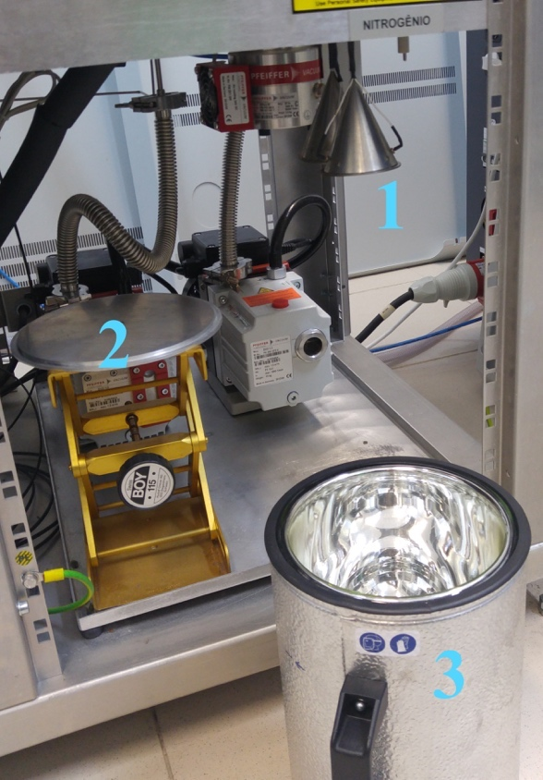 | 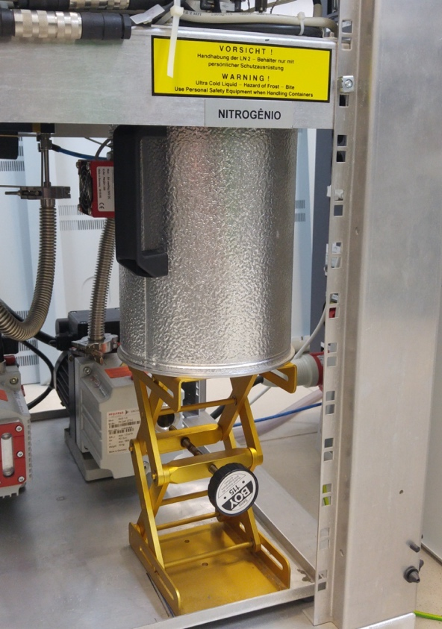
Figure 7. Lower part of the Kiel IV. On the left panel: 1 CO₂ traps. 2 Crane. 3 Small LN₂ reservoir. On the right pane: small LN₂ reservoir in position for analysis.

Upon departure
- Be sure that the primary LN₂ reservoir has enough pressure to transfer LN₂ to the Kiel IV. This is normally above 0.5 bar. If the pressure is lower, open carefully the manual pressure adjustment valve (Fig. 3 item 7) until having a stable pressure around 0.5 bar or above. IMPORTANT always close the manual pressure adjustment valve after opening it. Never leave it open unattended.
- Make sure the small reservoir is in position under the CO₂ traps of the Kiel (Fig. 7 right panel). If you are putting the small reservoir back into position be careful not to splash the LN₂ that is still inside the small reservoir. Insert the small reservoir slowly and use gloves.
- Switch off the microscope lamp.
- Put the microscope cover back on.
- Put the web cameras back into position for remote monitoring as in Fig. 8 upper panels (VERY IMPORTANT). Check the cameras field of view with the software ContaCam. The images should look similar to those in Fig. 8 lower panel.

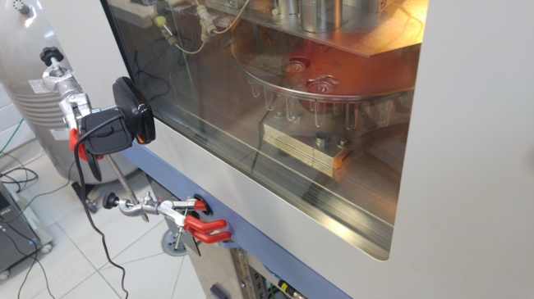 | 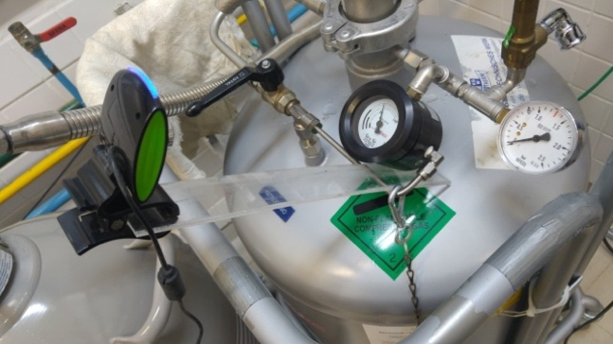
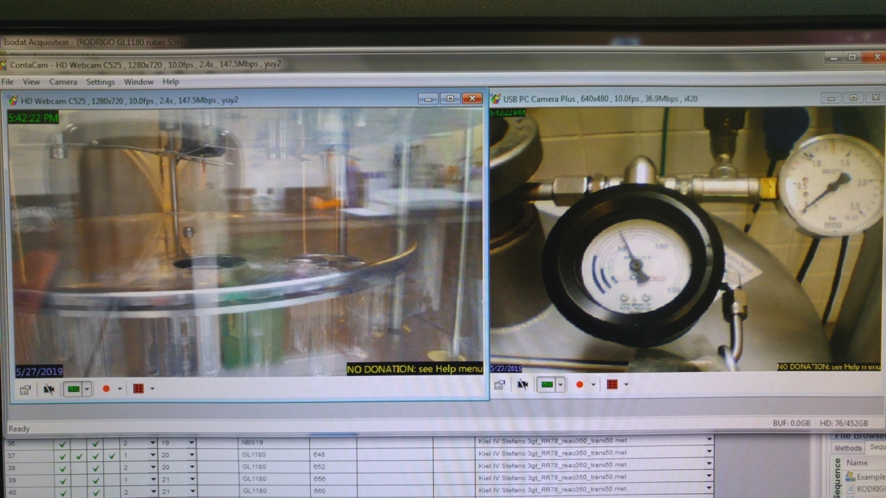
Figure 8. Upper panels: positions of the web cameras for remote monitoring. Lower panel: field of view of each camera.
- Check that the internet connection is working properly. If not please let know Rodrigo (Lab secretary) as soon as possible.
- Switch off the computer monitor.
- Clean the desk and leave the space tidy.
- Switch off the lab lights.
- Lock the lab door.

Handling samples, vials and magazine

Magazine sample distribution
Sample in the magazine must be placed according to the following scheme (Fig. 9).
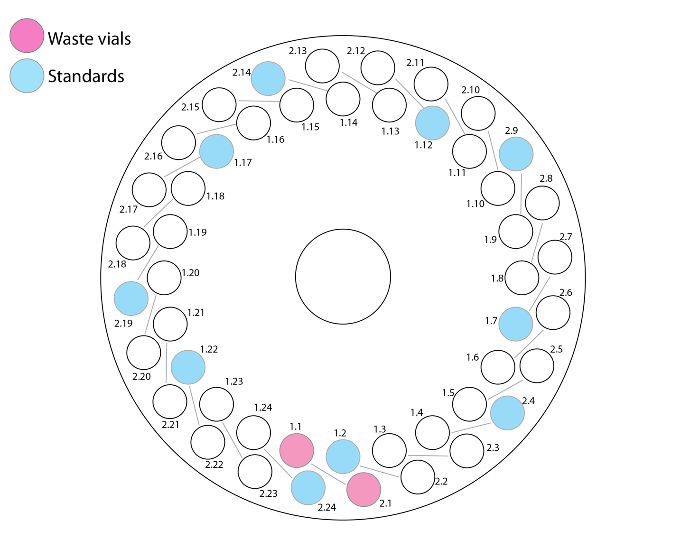
Figure 9. Sample placement for routine analysis. Each number in the number pair represents the line and position respectively. In pink is highlighted the position of the waste vials (empty vials). Note that samples 1.1 and 2.1 are not present in the sequence for this reason. In light blue are highlighted the position for the samples designated for the standards (one standard every four samples).
It is of paramount importance that the scheme represented in Fig. 9 is respected carefully. A similar markup is applied to the magazine itself as well. This scheme is the same present in the EMPTY SEQUENCE.seq file (see section 5).

Removing a magazine
- Make sure that the acquisition has finished.
- Make sure that all the samples have been analyzed and the is no samples that have been skipped. In order to do so, check the file size of the result for each sample (Fig. 10). The normal file size should be 124 KB. If the file size is only 61 KB it means that sample has not been analyzed. If so, take the sample and incorporate it in the next acquisition cycle.

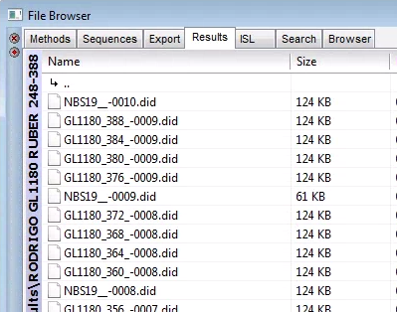
Figure 10. File browser window in the Isodat software where the file sizes of the results can be checked. If a file size has 61 KB that specific sample has been skipped. The reason or error can be checked in the file itself.
- Inside the Kiel IV status control window in Isodat software (Fig. 11) right click with the mouse anywhere and click on Take magazine.
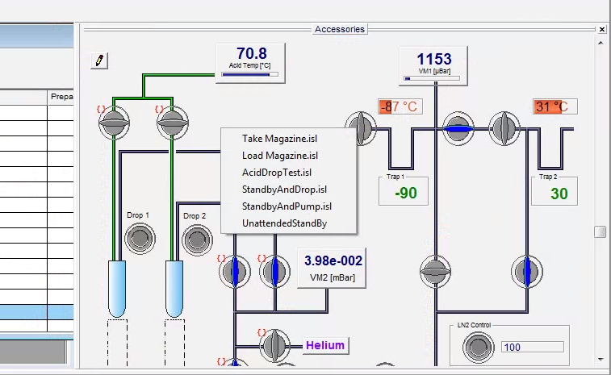
Figure 11. Kiel IV status control window inside Isodat software.
- When the message Ready to take magazine appears, you are ready to remove the magazine.
- Wear gloves and open the Kiel IV oven door. Gently raise the magazine half a centimeter to free up the pin from the slot of the motor and remove the magazine horizontally (see Fig. 12). IMPORANT be careful not to hit the acid needle in order not to damage it.
- Place the magazine on the dedicated support on the laboratory desk.
- Close the oven door.

Loading a magazine
- Place the magazine cap onto the magazine and rotate the magazine in order to have the position 1 appearing from the two holes of the cap.
- Wear gloves.
- Open the oven door and insert the magazine inside the Kiel IV. IMPORANT be careful not to hit the acid needle in order not to damage it.
- Make sure that the pin in the bottom of the magazine is aligned with the slot in the magazine motor (Fig. 12).

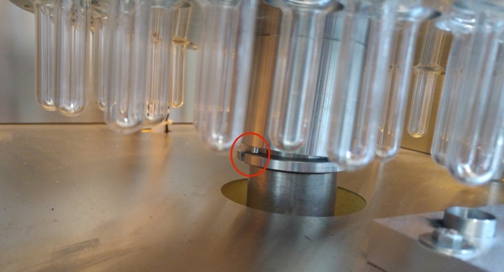 | 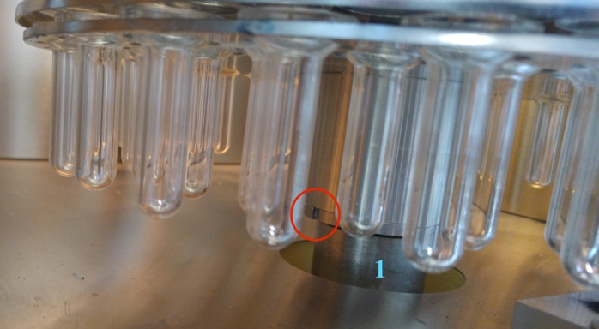
Figure 12. Wrong (left) and right (right) position of the magazine onto the magazine motor inside the Kiel IV. Left panel: note that the pin is not aligned with the slot on the motor (item 1). Right panel: the magazine is correctly aligned with the motor and the pin fell into the slot on the motor.
- Make sure that the magazine fork is aligned with the pin at the back of the oven cavity (Fig. 13).

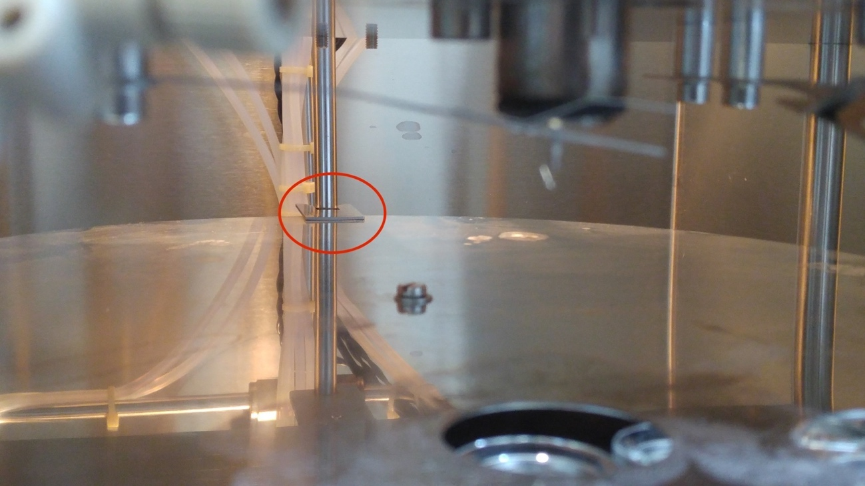
Figure 13. Alignment pin on the magazine cap. Make sure the fork on the magazine cap is placed as to catch the pin at the back of the oven cavity.
- Close the door.
- Inside the Kiel IV status control window in Isodat software (Fig. 11) right click with the mouse anywhere and click on Load magazine (Fig. 11).
- The Kiel will connect the first two vials to the acid blocks and a message saying Magazine ready will appear.
- Click ok and continue with your activities.

Basic maintenance between acquisitions
- Remove the small reservoir in the lower part of the Kiel IV and leave it aside about 30 min in order to let the CO₂ traps thaw (Fig. 7 left panel). If there is LN₂ inside the small reservoir, cover the top with the plastic disk you find in the box with the LN₂ accessories in order not to waste LN₂.
- If the small reservoir had the time to evaporate all the residual LN₂ and reach room temperature, remove the water/moisture that accumulated inside.
- Remove the magazine with the samples of the previous analysis cycle with the method described in section 3.2.
- With a lint-free tissue clean the head of the acid needle and the O-ring from any acid residue. In doing so be careful not to bend the drop counter away from the acid needle. The tip of the drop counter must be exactly below the acid needle (Fig. 2) otherwise the acid drop will land on the side of the vial and cause an uneven reaction with the sample.
- Load the magazine with the samples to be analyzed with the method described in section 3.3.
- Wait 10 minutes for the temperature inside the oven to stabilize at 70°C.
- Before starting a new acquisition make sure the small reservoir is in position under the CO₂ traps of the Kiel (Fig. 7 right panel). If you are putting the small reservoir back into position be careful not to splash the LN₂ that is still inside the small reservoir. Insert the small reservoir slowly and use gloves.
- Be sure that the primary LN₂ reservoir has enough pressure to transfer LN₂ to the Kiel IV. This is normally above 0.5 bar. If the pressure is lower, open carefully the manual pressure adjustment valve (Fig. 3 item 7) until having a stable pressure around 0.5 bar or above. IMPORTANT always close the manual pressure adjustment valve after opening it. Never leave it open unattended.
- Make sure the acquisition sequence is correctly set up (refer to section 5.1)
- Play the acquisition routine and set a proper folder name for the results.

Washing the vials
- Leave the vials few minutes on the laboratory desk to cool off a little.
- Fill the 1 liter Becker with tap water.
- Put the vials into the Becker making sure that each vial fills with water.
- Rinse the vials once by discarding the water and filling the Becker again with tap water.
- Discard the water.
- Switch on the washing machine.
- Press the lock button to open the main door.
- Place each vial on top of a needle.
- Close the door and select the program “F”.
- Press once the drying routine button (second button from the top) in order to increase the drying time by 40 minutes.

Handling liquid nitrogen

Safety concerns
PLEASE READ CAREFULLY!
Liquid nitrogen (LN₂) is an ultra-cold liquid that can cause serious hazard if handled improperly. Please take all the precautions when working with LN₂. Avoid direct contact with skin for prolonged time (more than 2 seconds). However, If you spill LN₂ on your gloves or clothes REMOVE THEM IMMEDIATELY. Frozen cloth and gloves can trap your hands and body parts and produce blisters that can be even more serious than dealing with LN₂ with bare hands.

EXPLOSION HAZARD!!
Avoid trapping LN₂ in any compartment of the LN₂ system at room temperature. LN₂ expands several hundred times at room temperatures causing very serious explosion if no safety valves are in place to avoid the buildup of pressure. The most common place for potential LN₂ trapping is between valve 5 and 4 (refer to Fig. 3), and inside the LN₂ transferring hose when both the valve 2 of Fig. 4 and valve 3 of Fig. 3 are closed (after an LN₂ transfer for instance). Always leave valve 3 of Fig. 3 open.

Transfer LN₂ from secondary to primary reservoir
- Prepare the two reservoirs for the LN₂ transfer following the setup as in Fig. 14.

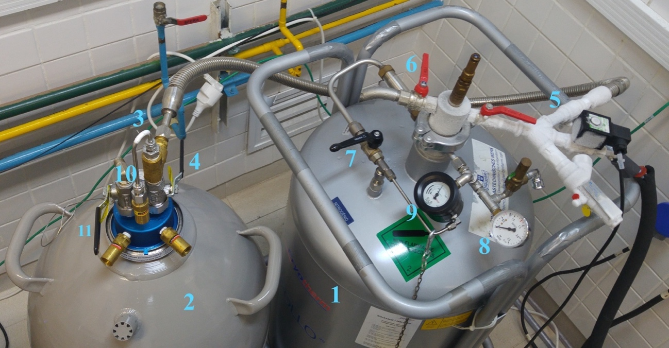
Figure 14. Setup for the LN₂ transfer between the secondary reservoir (2) and the primary reservoir (1). Connect the LN₂ transferring hose to the connection at (3). 6 Vent valve. 4 LN₂ transfer valve. 5 LN₂ transfer valve (not visible because underneath the pipe). 6 Shallow LN₂ access valve (vent valve for pressure release. 7 Manual pressure control valve.). 8 Pressure gauge. 9 LN2 level gauge.
- Connect the LN₂ transfer hose to the secondary reservoir (2) to the connector 3.
- Release the pressure inside the primary reservoir (1) by opening a little valve 6.
- Increasingly open valve 6 to release the pressure without too much N2 flow from the vent.
- When ALL the pressure has been released from the primary reservoir open valve 5. The valve is underneath the pipe, and the handle is placed on top of the plug on the wall next to the reservoir.
- Open half way valve 4 from the secondary reservoir to start the flow of LN₂. You will notice an increase in flow of N2 from the vent of the primary reservoir. This is because the hose is at room temperature and the LN₂ evaporates completely before reaching the primary reservoir boiling off the LN₂ that is already inside the primary reservoir.
- When frost builds up on the hose and the N2 flow from the vent reduces a bit, open valve 4 completely. Now the hose is refrigerated and LN₂ is liquid during the transfer.
- Await the transfer of LN₂, this can take several minutes.
- Monitor the level of LN₂ on the LN₂ level gauge (9).
- Monitor the pressure on the secondary reservoir with the pressure gauge (10).
- At around 0.2 bar on the secondary reservoir or after the transfer of around 30-40 liters on LN₂ terminate the transfer. Do not transfer all the LN₂ from the secondary reservoir in order to avoid the discharge of the insulation power of the secondary reservoir.

- To terminate the transfer first close valve 4 on the secondary reservoir.
- Close valve 6 on the primary reservoir.
- Wait the hose and pipes to defrost a little bit. This ensures that the LN₂ in the hose evaporates and expands into the primary reservoir, avoiding risk of explosion.
- Close valve 5 of the primary reservoir.
- Disconnect the LN₂ transferring hose from the secondary reservoir. Do this slowly anyway in order to not to risk sudden pressure release. Be careful not to drop the hose on the ground.
- Use the manual pressure control valve (7) to manually increase the pressure. Monitor the pressure with the pressure gauge (10). Ideal pressure for operation is above 0.5 bar.

Preparing the reservoirs for LN₂ refill
- Disconnect the LN₂ transferring hose from the secondary reservoir (connector 3) if not already disconnected.
- Release the pressure from both reservoirs using valve 6 and valve 11. Leave the valves open.
- After all the pressure has been released, release the collars from both heads of the reservoirs.
- Remove the heads, place them on the ground and place the caps into the reservoir’s necks.
- Place the reservoirs outside the lab for the operator to make the refill.
- Place the heads back into the reservoir. Make sure valves 6 and 11 are open. Place the heads into the reservoir slowly in order not to splash LN₂ outside and on yourself.
- Seal the heads with the collar provided with the reservoir. On the secondary reservoir connect the steel cable to the ring underneath the pressure gauge.
- Check that the collar is properly seated on the reservoir neck and properly sealed.
- Close valves 6 and 11 and allow pressure to increase inside the reservoirs.
- Use the manual pressure control valve (7) to manually increase the pressure. Monitor the pressure with the pressure gauge (10). Ideal pressure for operation is above 0.5 bar.

Sequences and acquisition

Building a sequence and starting an acquisition
- Open Isodat Workspace.
- Select the Sequences tab in the File Browser window on the left side (Fig. 15).

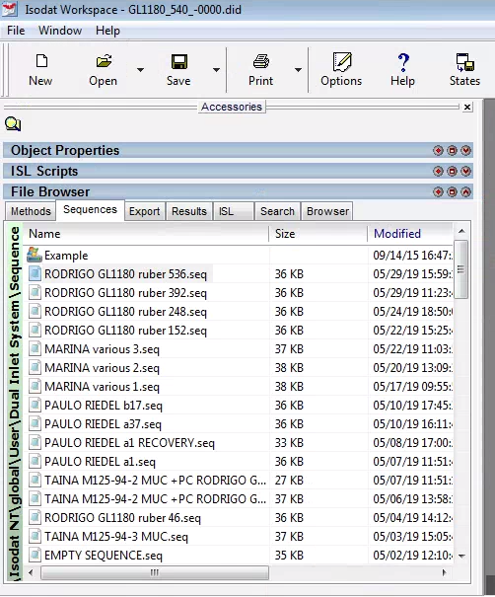
Figure 15. Sequences tab in the File Browser window in Isodat Workspace.
- Double click on the file EMPTY SEQUENCE.seq. The sequence window will appear on the right side as in Fig. 16.

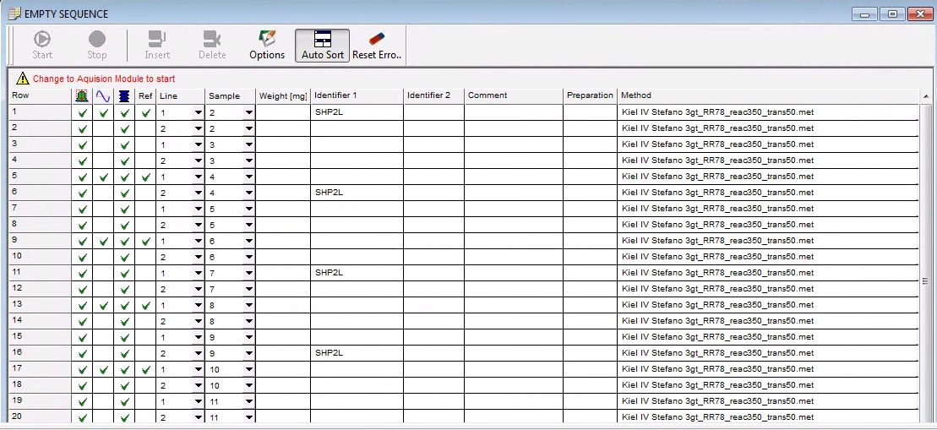
Figure 16. EMPTY SEQUENCE.seq
- Fill up the sequence according to your samples. A few things to keep in mind:
- Always keep the position where SHP2L is present in the Identifier 1 column as designated position for the standard. See section 3.1 for the magazine sample scheme.
- Don’t change the ticks distribution at the left side of the spreadsheet.
- Change the name of the standard in case you are using NBS19 for instance. In this case the name should be exactly “NBS19”.
- In the column Identifier 1 place the general code that identifies the batch of samples. For example, “GeoBxxxx-x” or “GLxxxx”. Please be consistent.
- In the column Identifier 2 place the specific code that identifies the sample. Usually a number corresponding to the depth of the core or the number of the sample. This column must have numbers only.
- In the Comment column place any other critical information in order to further identify the sample. For example, the size fraction or the species name. This is optional though.
- Use the Preparation column in case you need an extra identifier or to make note of something important.
- Make sure that the method selected in the Method column is “Kiel IV 3gt_RR78_reac350_trans50.met”
- Save the sequence with “save as”. DON’T OVERWRITE THE EMPTY SEQUENCE.seq FILE. The name of the sequence should have the name of the client, the general identifier (e.g. GeoBxxxx-x), and the number of the first sample.
- Open Isodat Acquisition.
- Select the Sequences tab in the File Browser window on the right side (Fig. 15).
- Double click on the sequence that you just produced.
- Click the green play button in the upper left side of the sequence window.
- Set a folder name for the results and click ok. The folder should have the same name of the sequence plus the number of the last sample. For instance, if the file name of the sequence is RODRIGO GL1180 ruber 536.seq the results folder name should be RODRIGO GL1180 ruber 536-676.
- Keep an eye to the log window and stay in the lab until the first sample has been analyzed to make sure that everything runs smoothly.

Running a leak test on a vial
- Open Isodat Acquisition.
- Double click on the file EMPTY SEQUENCE.seq. The sequence window will appear on the right side as in Fig. 16.
- For the first two samples set the method in the Method column to “Vialtest.met”.
- Select the first two rows of the sequence.
- Click the green play button in the upper left side of the sequence window.
- Set a proper folder name for the results (e.g. Leak rate test dd_mm_yy) and click ok.

Monitoring an acquisition check-list
- Open Isodat Acquisition and check in the log at the bottom of the window if the acquisition is still running.
- Open Isodat Workspace.
- Select the Results tab in the File Browser window on the left side (Fig. 17).

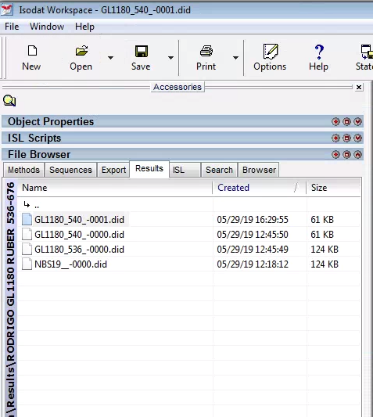
Figure 17. Results tab in the File Browser window in Isodat Workspace.
- Double click on a file of a sample or standard.
- On the Raw < CO₂> tab, check the signal intensities in the first column. They should be above 2000 mv ideally (Fig. 18).

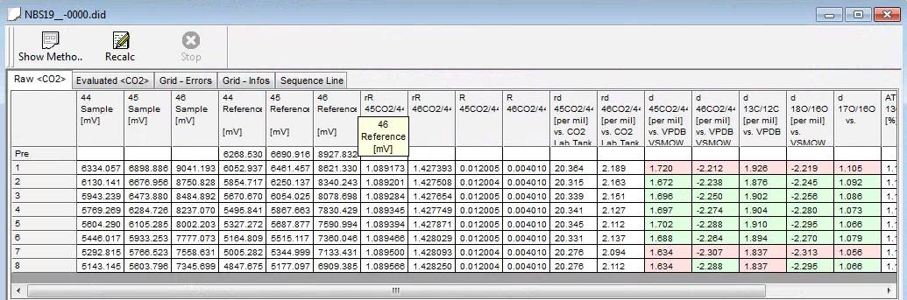
Figure 18. Raw < CO₂> tab in the result file in Isodat Workspace.
- In the Evaluated < CO₂> tab, check if the isotopic values make sense (Fig. 19).
- Check the internal standard deviation that should be always below 0.05 per mil.
- If anything is overtly wrong, like huge isotopic values or huge std. deviation, stop the acquisition immediately in order not to lose samples.

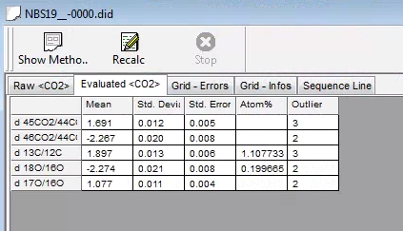
Figure 19. Evaluated < CO₂> tab in the result file in Isodat Workspace.
- In the Grid – infos tab, check the leak rate. It should be below 1000 μbar/min.

Emergency operations

Emergency switch off of MAT253+Kiel IV
In case the equipment has to be switched off please carefully follow the instructions below. Bear in mind that a switch off of the equipment should be avoided at all costs. So, unless power shortage is being threatened and the backups equipment are failing or offline, accept no justification or motivation, even from higher authorities, to have the equipment switched off. Contact immediately Prof. Dr. Cristiano Mazur Chiessi or Dr. Stefano Crivellari if such circumstances occur.

- Disconnect any connected vial and remove the magazine. See section 3.2.
- Configure the valves in the Kiel IV and Dual Inlet status control window exactly as shown in Fig. 20.

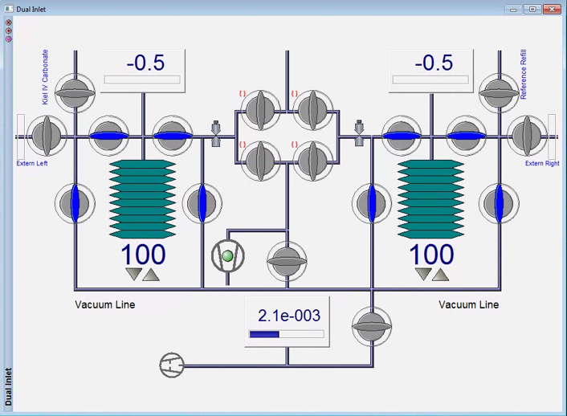 | 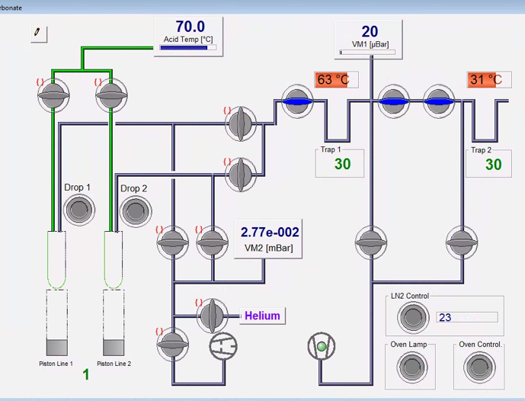
Figure 20. Valve status for switch off routine. Left panel refers to the Dual Inlet system. Right panel refers to the Kiel IV system.
- Switch off the oven lamp and the oven control (Fig. 20 right panel, buttons at the bottom right corner)
- If not set up already, change the traps temperature to 30°C (Fig. 20 right panel, click on the green numbers to change the temperatures)
- Switch off the filament and the high voltage using the buttons 1 and 2 (gray) highlighted in Fig. 21.

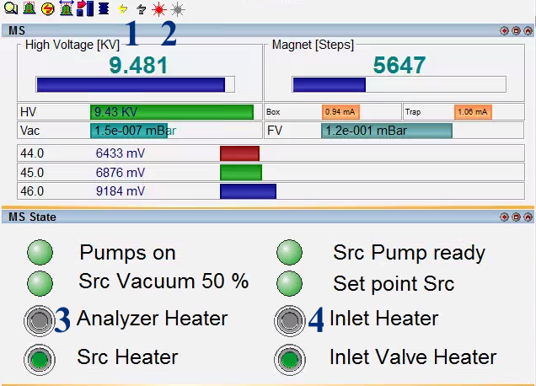
Figure 21. MAT status window. 1 On and Off buttons for the filament. 2 On and Off buttons for the high voltage. 3 Button for the Analyzer Heater. 4 Button for the Inlet Heater.
- Close the Acid flow valve (Fig. 1 item 8).
- Close the CO₂ reference gas tank valve.
- Switch off the turbo pumps using the switch on the control panels of the Kiel IV and the MAT (Fig. 5).
- Close all instances of Isodat and switch off the computer.
- Switch off the main energy supply with the red knobs on the back of the Kiel IV and MAT.

Switch on the MAT253+Kiel IV
Beforehand make sure that the no-break and backup generator are working properly.
- Switch on the main energy supply with the red knobs on the back of the Kiel IV and MAT.
- Make sure the air compressor is working properly and has 5 bar of pressure (Fig. 6 item 4).
- Switch on the computer, log in using the password 7157 and open Isodat acquisition.
- Wait for the host connection to be established (see Fig. 5).
- Switch on the turbo pumps using the switch on the control panels of the Kiel IV and the MAT (Fig. 5). This can take up several minutes. More than one attempt might be needed, await few minutes between attempts.
- Load a magazine and connect two vials to the acid block. See section 3.3.
- Switch on the oven lamp and the oven control (Fig. 22 right panel, buttons at the bottom right corner)
- Configure the valves in the Kiel IV and Dual Inlet status control window exactly as shown in Fig. 22.

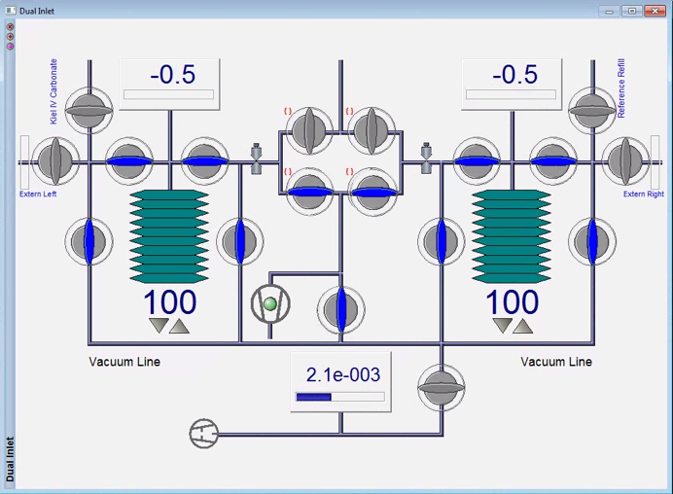 | 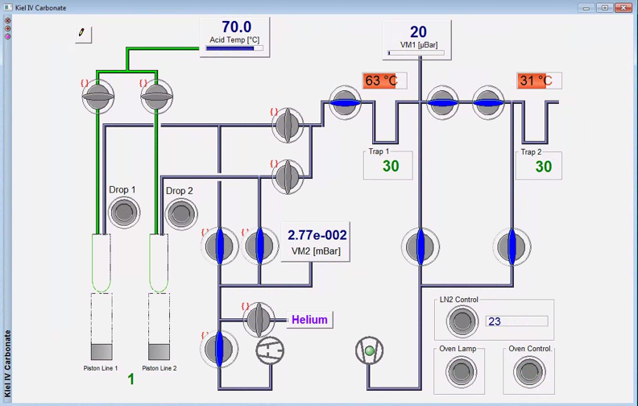
Figure 22. Valve status for switch on routine. Left panel refers to the Dual Inlet system. Right panel refers to the Kiel IV system.
- Monitor the vacuum being obtained in the Microvolumes, Analyzer and Dual Inlet.
  - In the Mircovolume ca. 40 mbar is nominal.
  - In the Analyzer 10⁻⁷ – 10⁻⁸ bar is nominal.
  - In the Dual Inlet ca. 10⁻² bar is nominal.
- When nominal pressures are being obtained it is safe to switch on the filament and the high voltage using the buttons (colored) highlighted in Fig. 21 (items 1 and 2).
- Open the Acid flow valve (Fig. 1 item 8).
- Open the CO₂ reference gas tank valve.
- If the machine has been switched off for a long period, or if the analyzer compartment has been open for maintenance, switch on the Analyzer Heater (Fig. 21 item 3). Leave it on for maximum 24 hours. Never switch on the Inlet Heater as this might cause leak in the inlet valve.
- After 48 hours the CO₂ background level should be below 20 mv for the cup #2.
- Change the mass in the second collector to check for contamination.
  - Mass 44 (CO₂) background level should be below 20 mv for the cup #2.
  - Mass 18 (H₂O) should be below 500 mv for the cup #2.
  - Mass 40 (Argon) should be below 50 mv for the cup #2.
- If everything is nominal run a series of autofocus and pass configuration to maximize sensitivity.
- Run a series of zero-enrichment tests to check for linearity.

Stand-by in case of potential energy drop
- Configure the valves in the Kiel IV and Dual Inlet status control window exactly as shown in Fig. 20.
- Switch off the filament and the high voltage using the buttons 1 and 2 (gray) highlighted in Fig. 21.
- Switch off the oven lamp and the oven control (Fig. 20 right panel, buttons at the bottom right corner).
- If not set up already, change the traps temperature to 30°C (Fig. 20 right panel, click on the green numbers to change the temperatures).
- Close the Acid flow valve (Fig. 1 item 8).
- Close the CO₂ reference gas tank valve.

Troubleshooting

Compressed air leak
In most cases the leak is at the level of a fast connector of the Kiel IV pneumatic system since these are the weakest parts. Leaks in the compressed air system are detectable by listening at the hissing noise in the fast connectors. Clues indicating that there is a leak are: (i) the air compressor is always on, or most of the time. (ii) unusual amount of water is being trapped in the water trap of the compressed air line (Fig. 6 item 1). If you are having trouble finding the leak or you are not sure, produce some foam with dish soap and a sponge and put some foam onto the various pneumatic fast connectors to see where it is bubbling.
- Identify the leaking fast connector. Usually this is associated to the operation of a pneumatic valve in the Kiel IV (lower part).
- Identify the associated valve and set the valve open in the Kiel IV status control window inside Isodat software. When the valve is open no compressed air is being fed to the valve allowing a disconnection of the tube.
- Disconnect the plastic tube by pressing the plastic ring of the fast connector toward the connector itself (this releases the tube from the connector) and by pulling the tube away from the connector.
- Unscrew the fast connector and substitute with a new one.
- Cut 1 cm of the tube in order to have a fresh tube ending.
- Plug the tube back into the new connector.
- Test the valve by closing it via Kiel IV status control window inside Isodat software. No hissing sound should be heard.
- If the leak is substantial and cannot be resolved quickly immediately put the equipment in standby by following the procedure described in section 6.3 and contact the lab manager immediately (lab manager contact can be found in section 8).

Leak rates are too high
Refer to section 5.3 to check leak rates during an acquisition.
Normally, it is unusual that leak rates are associated to a real leak however if during an acquisition this occurs follow the instructions below.
- Remove the vials from the acid blocks and remove the magazine.
- Clean the acid needle and acid block from any residue of liquid phosphoric acid.
- Insert a magazine and connect a vial on the two lines.
- Run a leak test. Refer to section 5.2 to run a leak test.

- If leak rates are still high than follow the instructions below.
- Remove the vials from the acid blocks and remove the magazine.
- Wrap a lint-free tissue to a plastic stick (for this purpose the acid test strips can be used, they can be found on the white tray on the lab desk).
- Clean the inside of the acid block with the tissue wrapped onto the stick. Be careful not to break the tissue and leave fibers inside the acid block. Be careful not to bend the drop counter as well.
- Insert a magazine and connect a vial on the two lines.
- Run a leak test. Refer to section 5.2 to run a leak test.

- If leak rates are still high than follow the instructions below.
- Remove the vials from the acid blocks and remove the magazine.
- Place some high vacuum grease (it can be found in the first drawer of the black cabinet) with a finger on the inner surface of an empty vial. A VERY small amount (a microfilm) is sufficient.
- Place the vial with the grease in contact with the O-rings of the acid block (Fig. 2 item 4).
- Run a leak test. Refer to section 5.2 to run a leak test.

- If leak rates are still high than follow the instructions below.
- Remove the O-ring from the acid block and throw it away. Rub a microfilm of grease onto a new O-ring (they can be found in the second drawer of the black cabinet). A VERY small amount (a microfilm) is sufficient. Place the new O-ring onto the acid block as in Fig. 2 item 4.
- If leak rates are still high than dismounting the acid block might be necessary. Contact the lab manager in case anything else did not work.

Problem with the drop counter
The acid drop counter is constituted by a simple circuit. The acid needle is shortened to ground by the presence of an acid drop that closes the circuit with the ground through the drop counter piece (Fig. 2 item 2). Sometimes can occur that the acid needle gets shorten to ground though the presence of a microfilm around the acid line capillary (Fig. 1 item 7) making the software to perceive a continuous flow of acid or a leak. Therefore, the system gets in acid safety mode by locking up the acid valves through an emergency backup system (see Fig. 23).

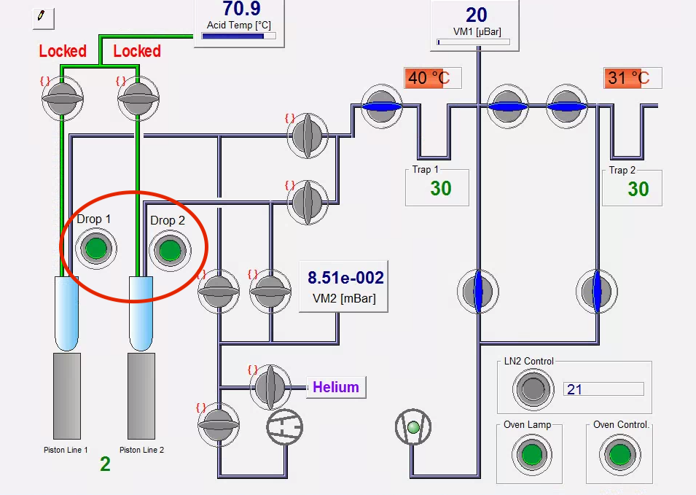
Figure 23. Configuration of a locked acid valves due to short circuit of the acid needle to ground.
If the two drop counters sensors get triggered at the same time, the problem is a short circuit through the plastic acid capillary which is connected to both capillaries through the T joint of the acid line capillary.
To solve the issue just rub a lint-free tissue on to the acid capillary and clean any acid residue. Pen attention to the amount of Acid that is being deposited. If it is more than a microfilm than the leak needs to be resolved by substituting the connector of the capillary to the acid valve.

Contact of Lab manager and Lab secretary

Lab Manager
Dr. Stefano Crivellari
Email: crivellaris@gmail.com
Email: stefano.crivellari@usp.br
Mobile: +55 11 971735067

Lab Secretary
Dr. Rodrigo Lucena
Email: rodrigo.lacite@gmail.com
Phone: +55 11 3091 8119
Mobile: -55 11 983145572

Principal Investigator
Prof. Dr. Cristiano Mazur Chiessi
E-mail: chiessi@usp.br
Phone: +55 11 26480124
Mobile: +55 11 985118548

